TOTAL MARKS: 25 DURATION: 45 MINUTES

EMPLOYEE NAME: EMPLOYEE ID:

**----------------------------------------------------------------------------------------------------------**

1. Go through the following code

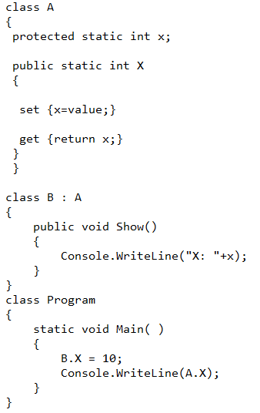

State which of this statement is correct?

1. The output of the program will be 10
2. The program will generate an compiler error
3. The output of the program will be 0
4. Though B.X=10 is possible but no value can retrieved by A.X and program will throw a runtime error
5. Match the following:

Extension Description

1. .cs A. Organizes projects, project items, and solution items in the

solution.

2. .sln B. Represents forms, user controls, classes and module files

that belong to a project.

3. .csproj C. Represent the class file.

Which of the following combination is correct?

i) 1-C, 2-A, 3-B

ii) 1-A, 2-B, 3-C

iii) 1-B, 2-C, 3-A,

iv) 1-B, 2-A, 3-C

1. Go through the following code

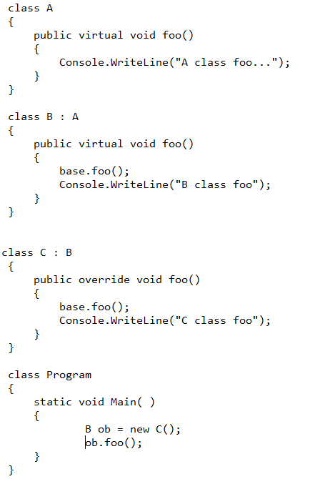

State which of the following output will be correct

1. output will be:

A class foo

B class foo

C class foo

1. output will be: B class foo
2. output will be :C class foo
3. Which one is not the component of an assembly?
   1. Manifest
   2. Type metadata
   3. Resources
   4. GAC
4. Go through the following code

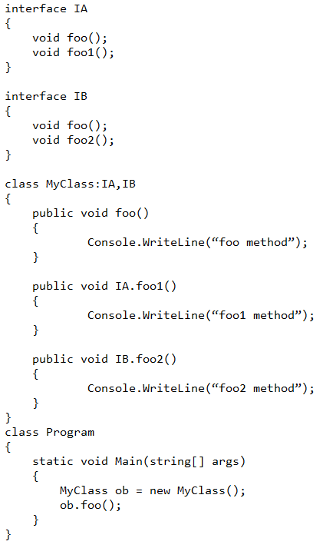

What of the following statements is correct?

1. The program runs without any error
2. Program generates an error because you can’t use ‘public’ keyword in the line ‘public void IA.foo1()’ and ‘public void IB.foo2()’
3. Program generates an error because you can’t implement two interfaces in a class
4. Program generates an error because you can’t craete an object of ‘MyClass’, because it has two explicitly defined functions of two different interfaces
5. Find out the correct array declarations
6. int [ , ] myarray=new int [ , ] {(1,2), (3,4)};
7. int [ , ] myarray={(1,2), (3,4)};
8. myarray={(1,2), (3,4)};
9. 1,2,3
10. 1,2
11. 2,3
12. Find out that whether the following inheritance is possible or not.

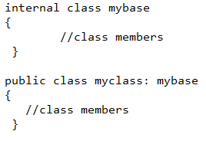

* 1. Possible
  2. Not Possible

1. In C#, how many access modifiers can be used with method of class, from the following list?
2. Virtual 2. Abstract 3. Override 4. Sealed
3. 1,2,3,4
4. 1,2,3
5. 1,3,4
6. None
7. State which of these following statements is correct.
8. All the interface members are by default private
9. All the interface members are by default public
10. All the interface members, when implemented in class, have to be declared with override keyword
11. Go through the following code

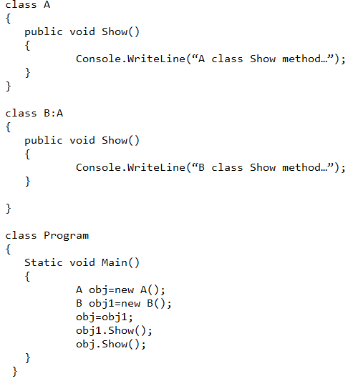

Which one of the following is correct answer?

1. The program shows an error
2. The output is “A class Show method“ and “B class Show method”
3. The output is “B class Show method” and “A class Show method”
4. The output is “A class Show method” and “A class Show method”
5. Which of the following statements is correct?
6. Structure is reference type
7. Structures are by default supplied with default constructor
8. I can write default constructor in the structure
9. Structure can have overloaded constructor as long as the constructor assigns values to all the variables declared in the structure
10. Which techniques, from the following list, are used to implement IOC?
    1. Dependency Injection 2. Service 3. Delegate 4. Event
    2. 1, 2, 3
    3. 1, 3, 4
    4. 2, 3, 4
    5. 1, 2, 3, 4
11. Which type of association, entities in the following diagram, share with each other?

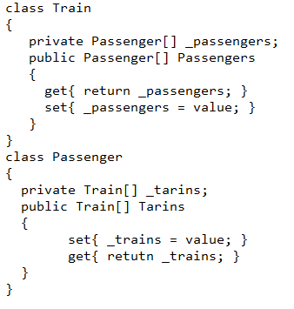

* 1. Association
  2. Composition
  3. Aggregation

1. Go through the following code…

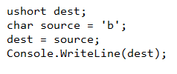

* 1. This is implicit data type conversion
  2. This is explicit data type conversion

1. Go through following code



* 1. Value of x is 10
  2. Value of x is 11
  3. Value of x ix 9

1. Reference type variables are stored in _________________________.
   1. Stack
   2. Heap
   3. Code Region
2. You have created a C# class file whose name is A.cs having a class A. You did not write Main function inside the class. Now you are trying to compile that file and you set /target: exe. What will be the consequence?
   1. the A.cs file will be compiled into A.exe
   2. the A.cs file will be compiled into A.dll
   3. The file will not not be comiled. Compiler will throw an error.
3. How many mistakes are there in the following code?

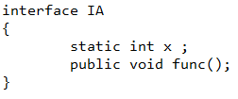

* 1. 1
  2. 2
  3. 3

1. if you want to access the keys and values stored inside the Dictionary<Tkey,Tvalue> generic class, then which of the following classes should be used to represent the key-value pair present inside the Dictionary<Tkey,Tvalue>?
   1. DictionaryEntry
   2. Object
   3. IList<Tkey,Tavlue>
   4. KeyValuePair<Tkey,Tvalue>
2. Which of the following code segment is correct?
   1. 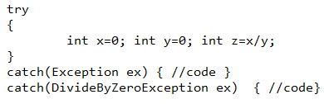
   2. 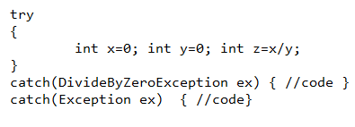

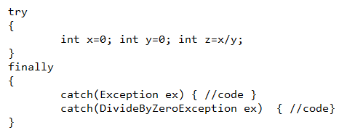

1. Go through the following code and select a correct option.

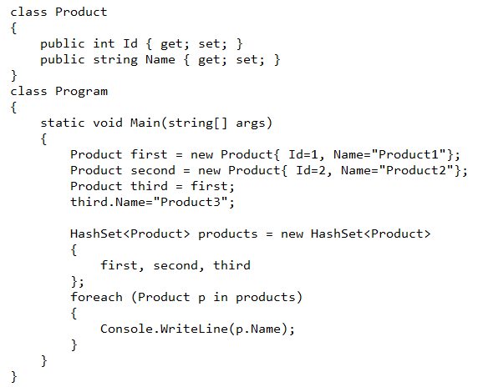

* 1. Output will be

Product1

Product2

Product3

* 1. Output will be

Product1

Product2

* 1. Output will be

Product2

Product3

* 1. Output will be

Product3

Product2

1. Go through the following code and select the best answer from the options mentioned below.

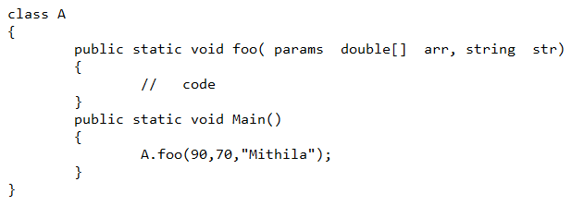

* 1. The code runs without any error.
  2. The code might throw exception during run time but will not throw any compile time error.
  3. The code throws a compile time error since param array declaration should be the last one in the function argument list of foo() function.

1. What is the correct difference between HashTable and SortedList?
   1. HashTable does sort all the objects placed in it by default, but SortedList does not do that.
   2. HashTable does not sort all the objects placed in it by default, but SortedList does.
   3. Both the collection classes do sort the objects placed in them by default.
   4. Both the collection classes do not sort the objects placed in them by default.
2. Which of the following features was introduced in the C# 4.0?
   1. Named parameters
   2. Partial class
   3. Extension Method
   4. Lambda expression
3. Which version of CLR will be used to run an application, if that application is created using .NET 3.5 Framework?
   1. 1.0
   2. 3.0
   3. 2.0
   4. 1.1